Perimeter and Area-Questions
Key Stage 3: 2003 Paper 1 Level 3-5
1.
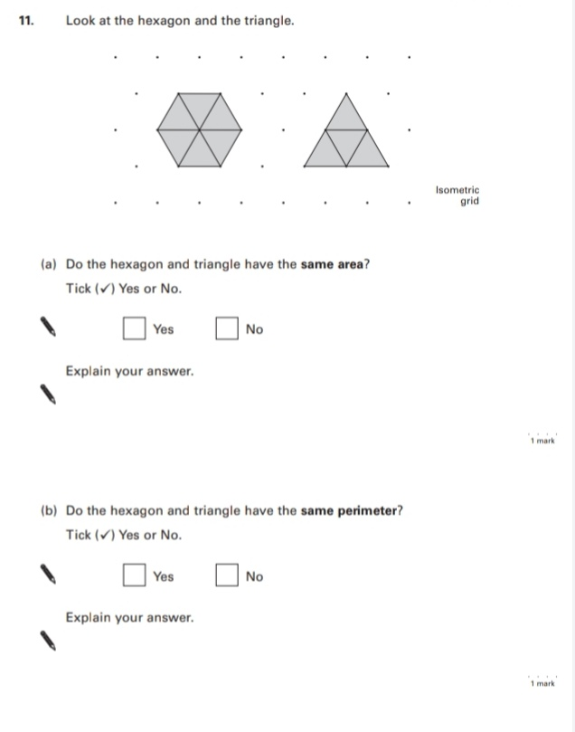
Key Stage 3: 2003 Paper 2 Level 3-5
2.
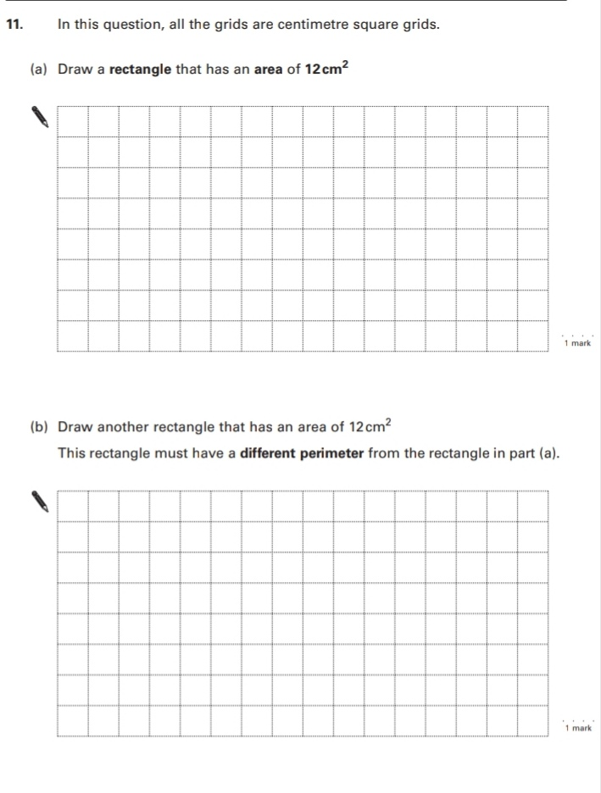
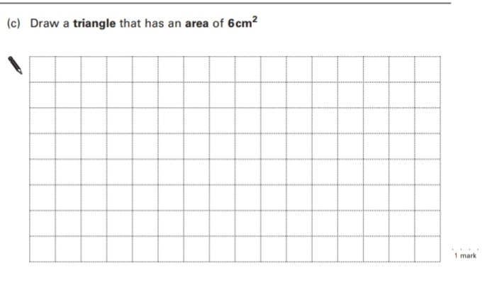
Key Stage 3: 2003 Paper 1 Level 4-6
3.
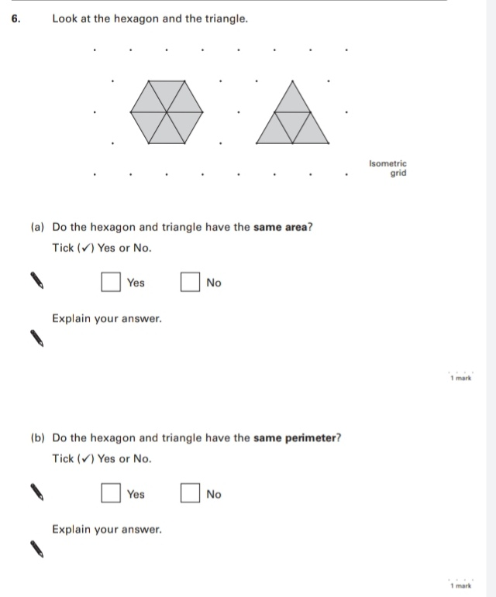
4.
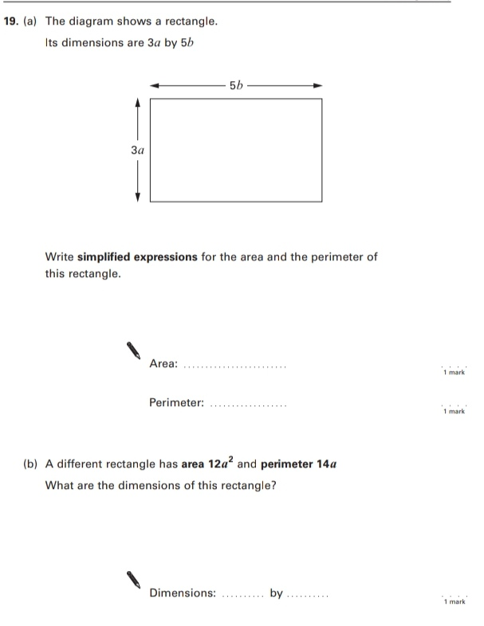
Key Stage 3: 2003 Paper 2 Level 4-6
5.
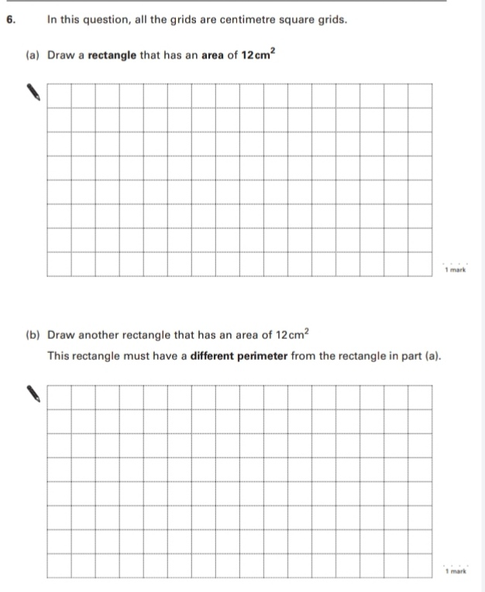
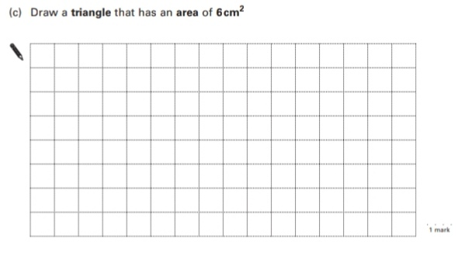
6.
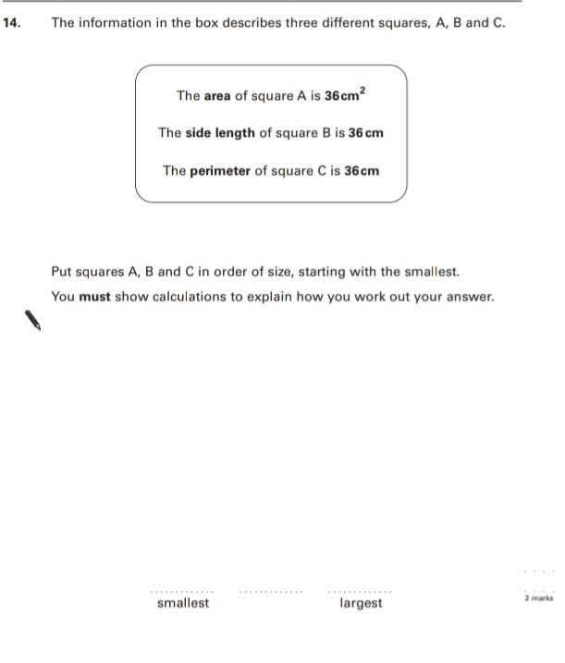
7.
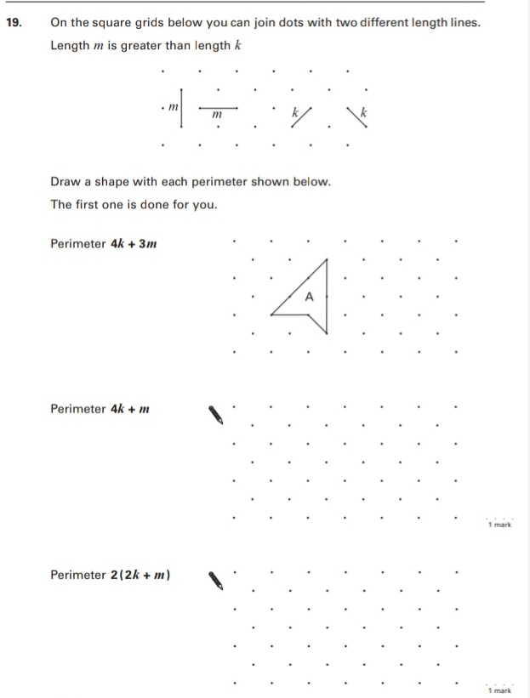
Key Stage 3: 2004 Paper 1 Level 3-5
8.
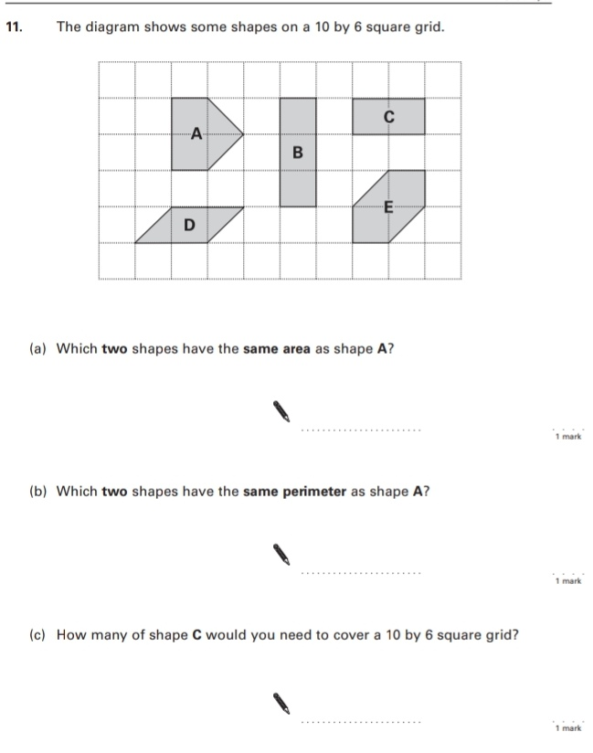
Key Stage 3: 2004 Paper 2 Level 3-5
9.
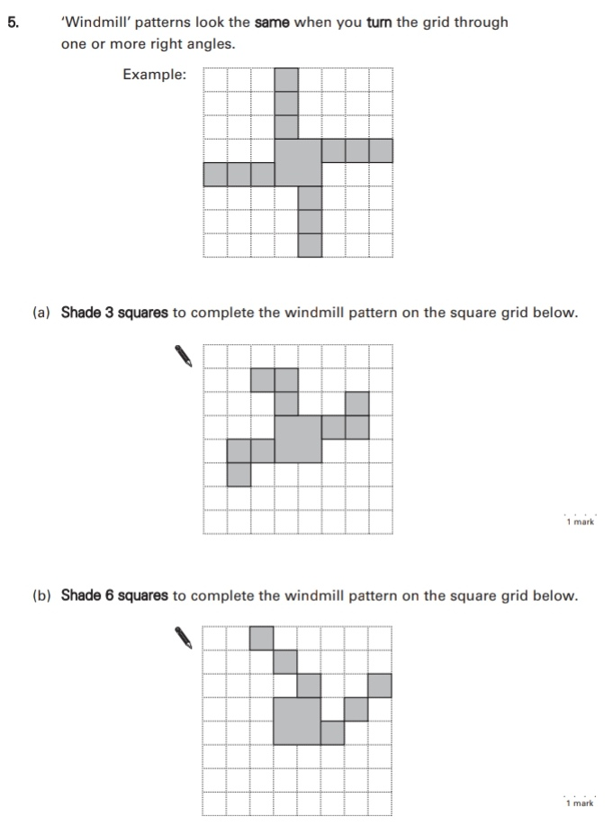
10.
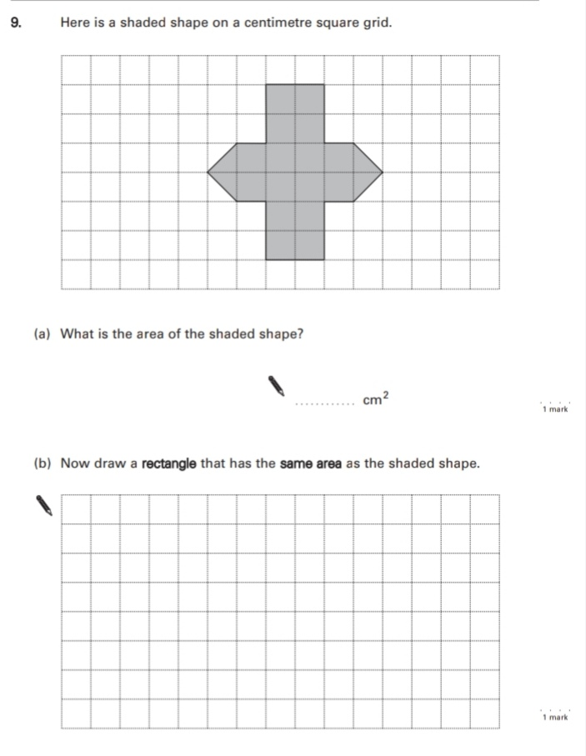
Key Stage 3: 2004 Paper 1 Level 4-6
11.
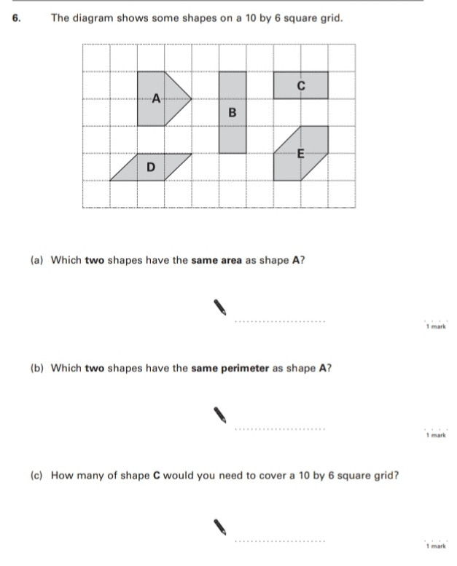
12.
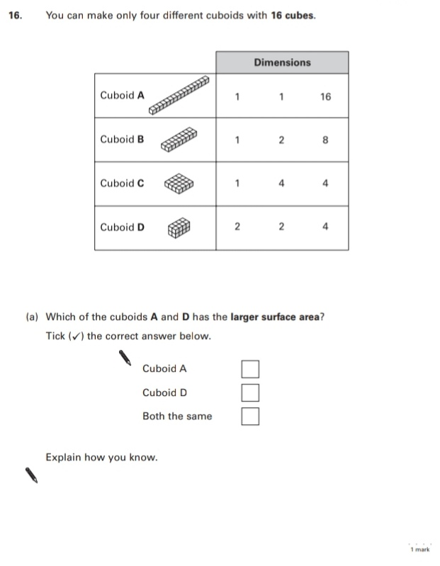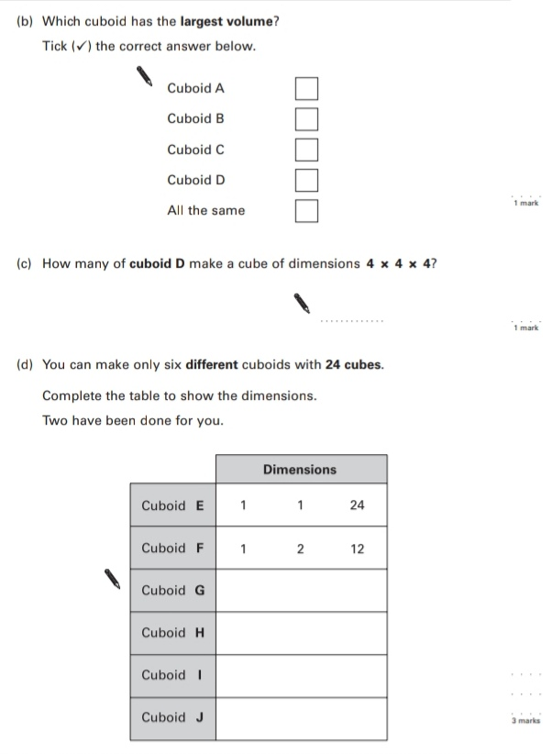
Key Stage 3: 2004 Paper 2 Level 4-6
13.
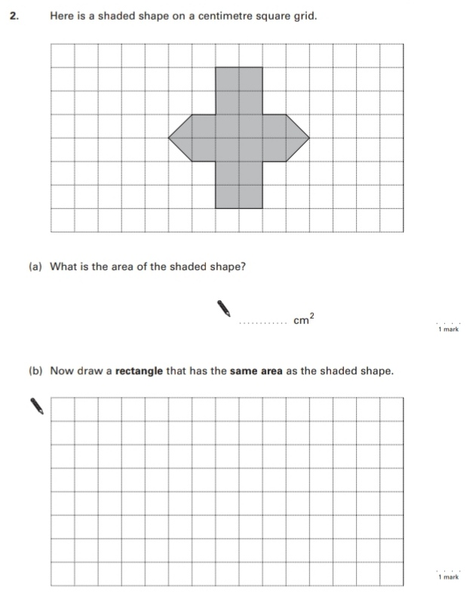
Key Stage 3: 2005 Paper 1 Level 3-5
14.
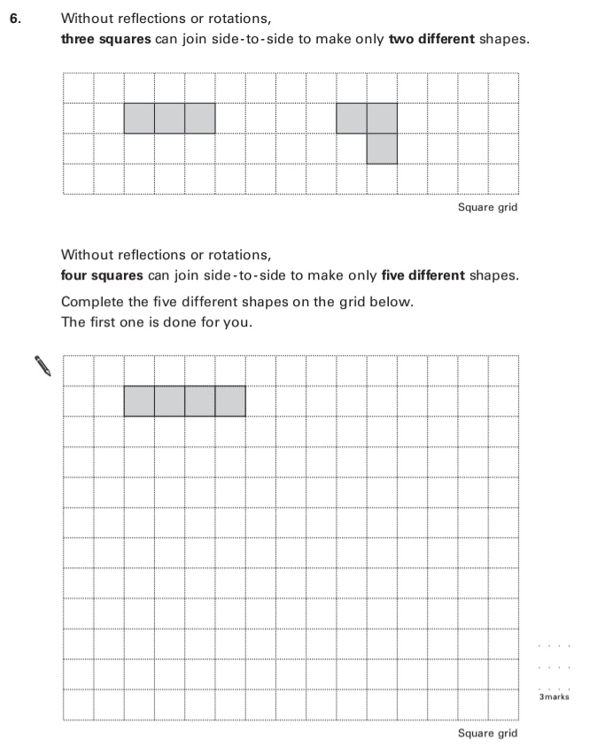
Key Stage 3: 2006 Paper 1 Level 3-5
15.
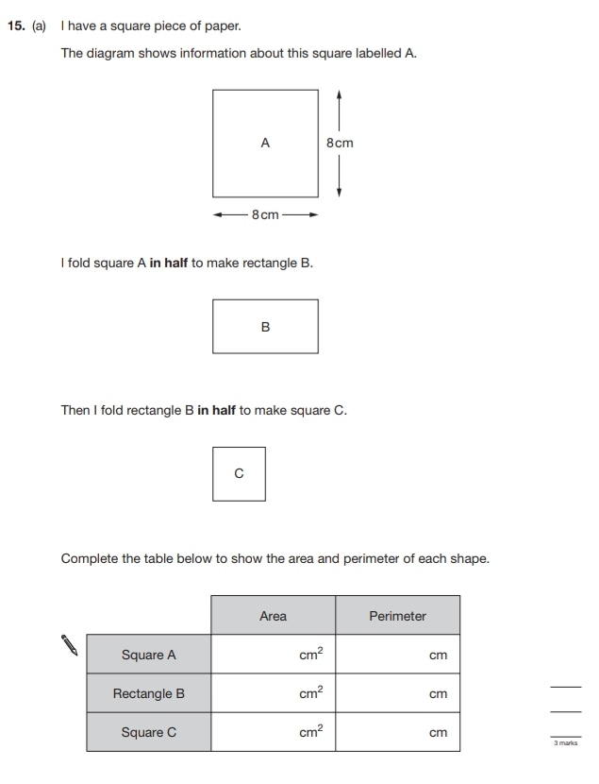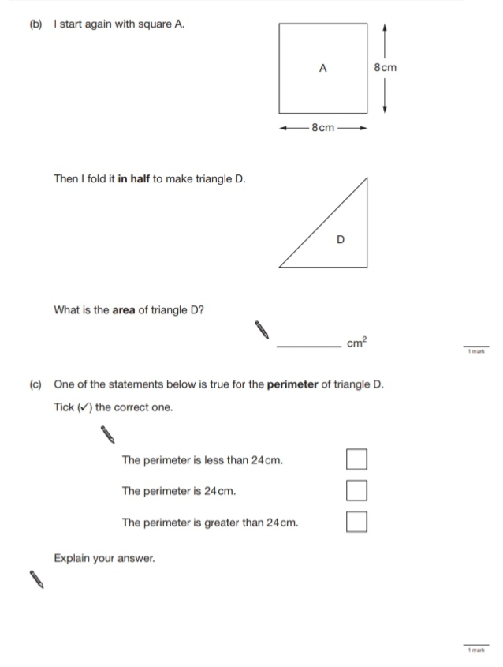
Key Stage 3: 2006 Paper 2 Level 3-5
16.
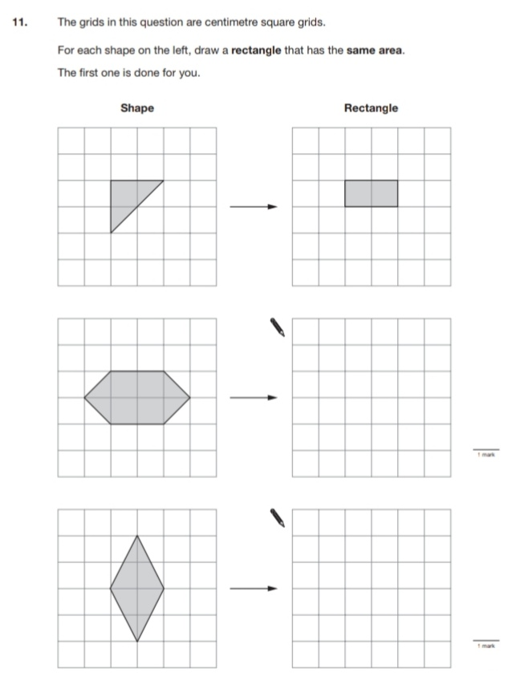
Key Stage 3: 2006 Paper 1 Level 4-6
17.
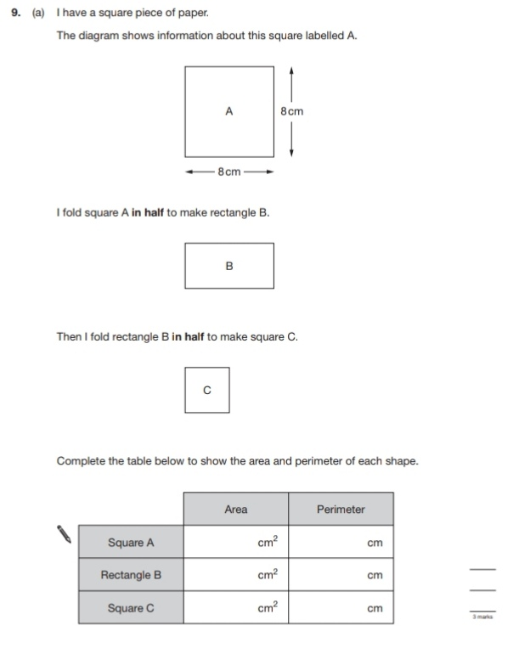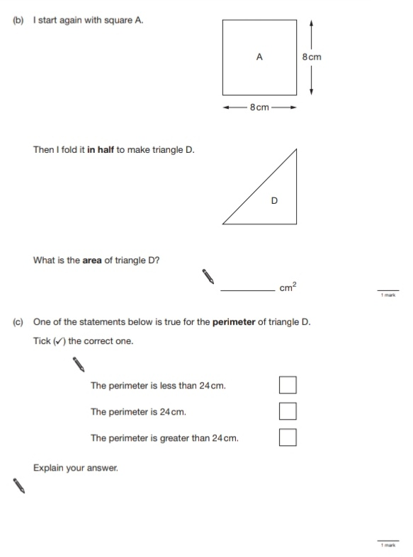
Key Stage 3: 2007 Paper 1 Level 3-5
18.
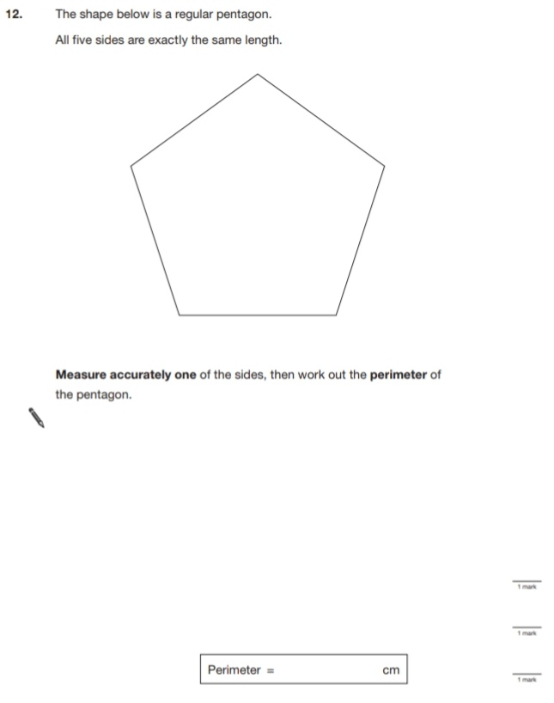
Key Stage 3: 2007 Paper 2 Level 3-5
19.
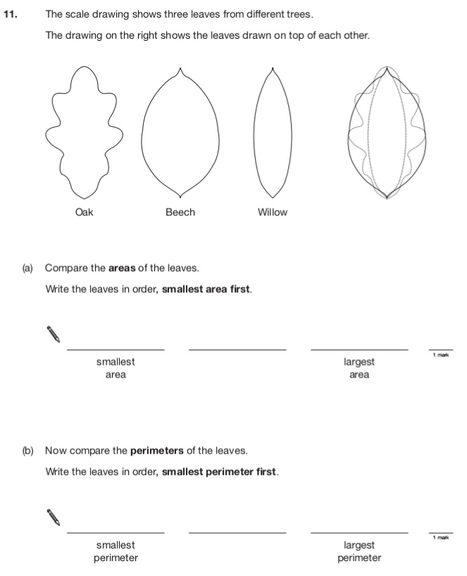
20
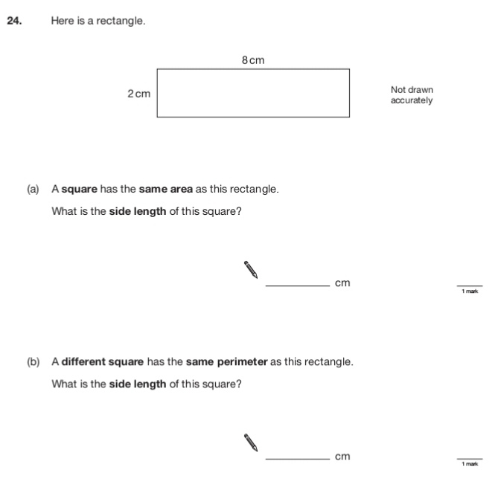
Key Stage 3: 2007 Paper 1 Level 4-6
21.
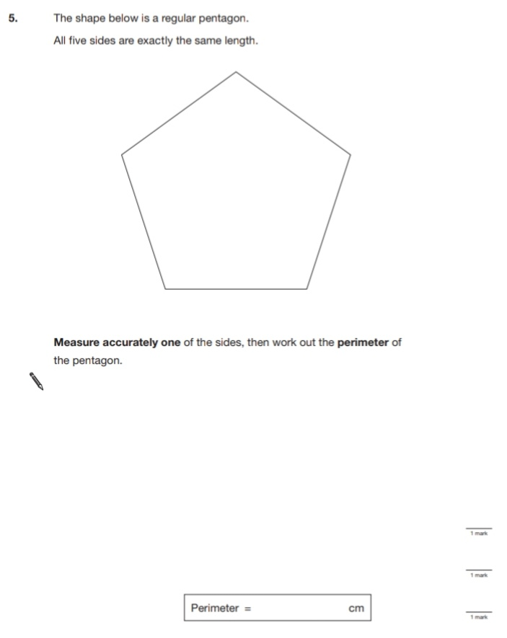
Key Stage 3: 2007 Paper 2 Level 4-6
22.
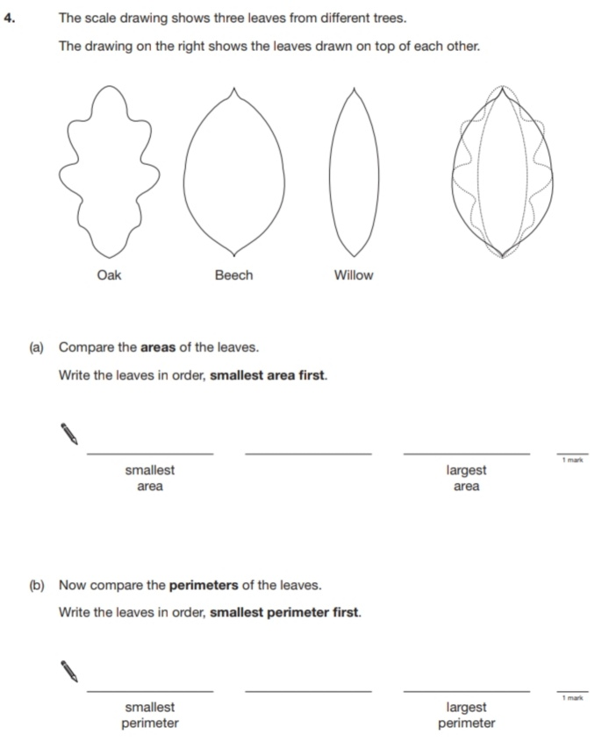
23.
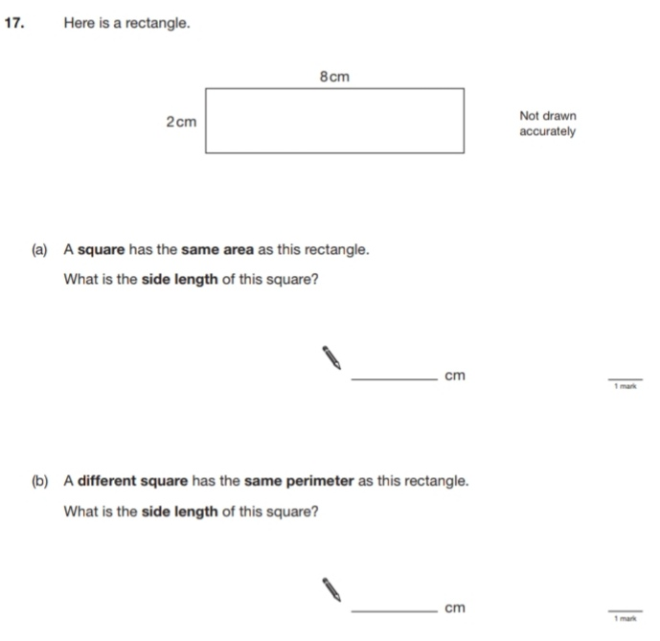
Key Stage 3: 2008 Paper 2 Level 3-5
24.
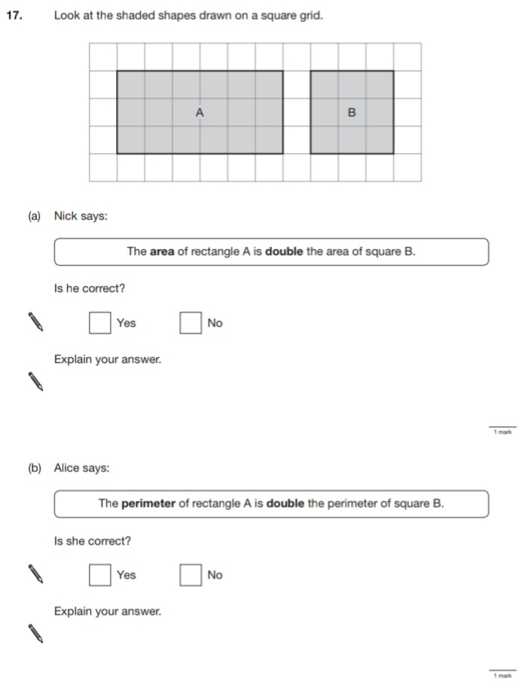
25.
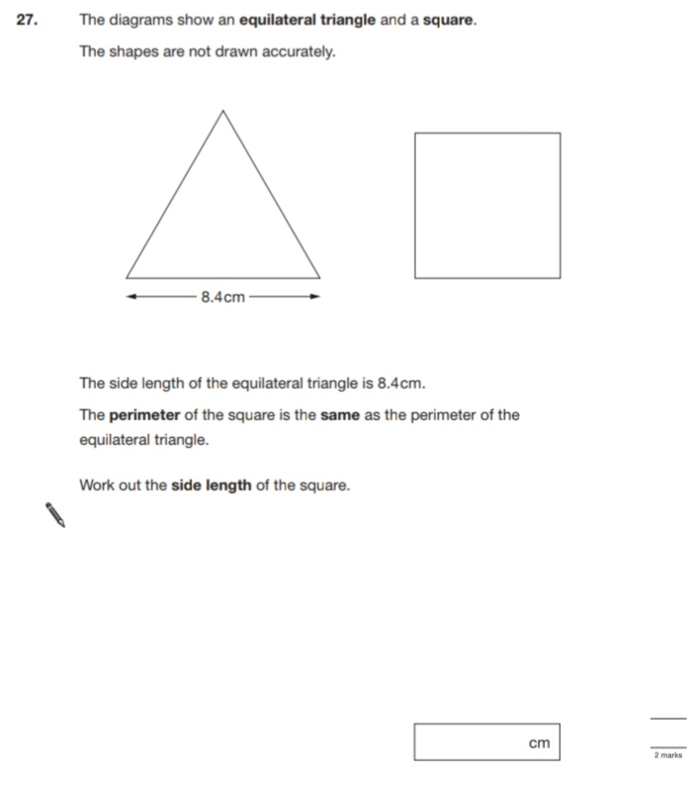
Key Stage 3: 2008 Paper 1 Level 4-6
26.
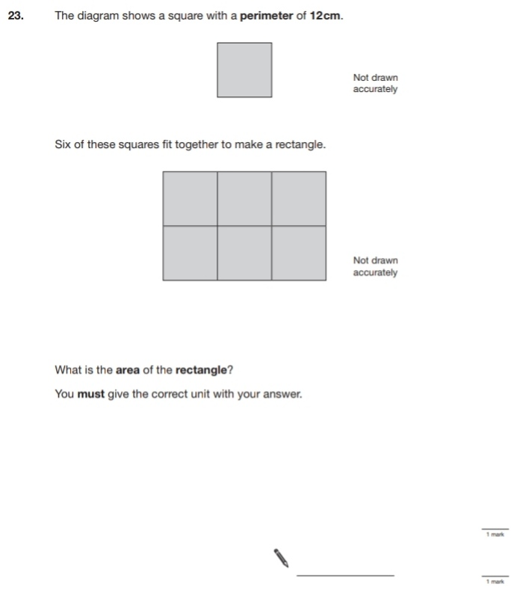
Key Stage 3: 2008 Paper 2 Level 4-6
27.
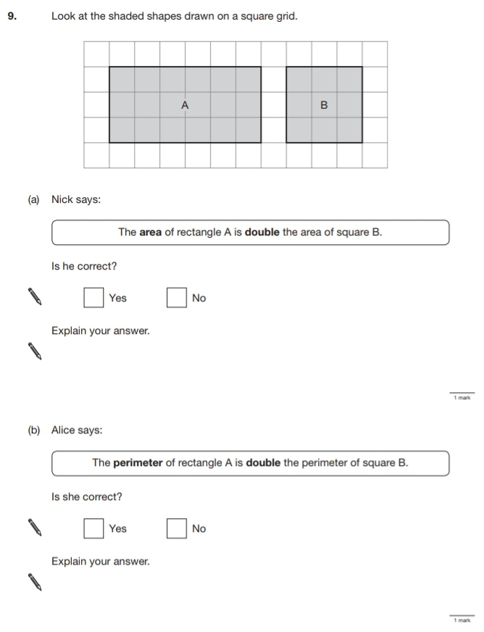
28.
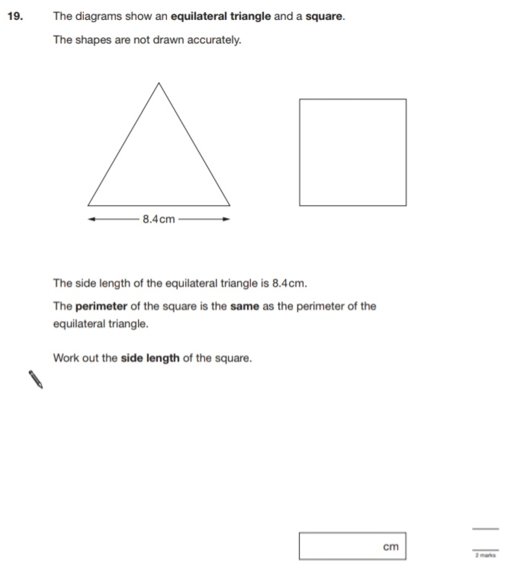
29.
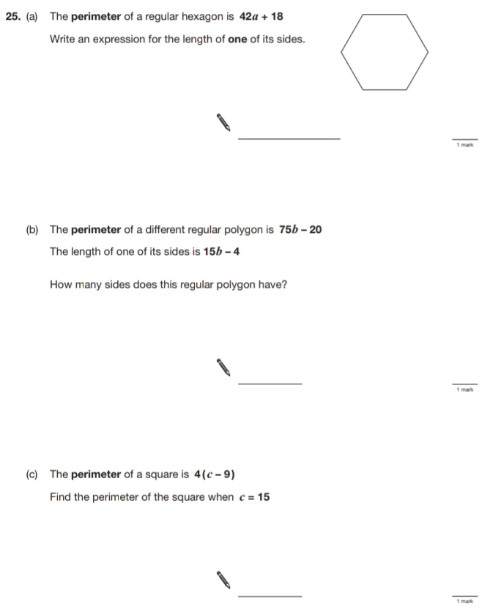
Key Stage 3: 2009 Paper 2 Level 4-6
30.
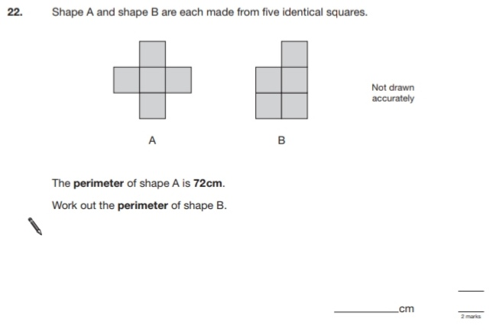
Key Stage 3: 2010 Paper 2 Level 4-6
31.
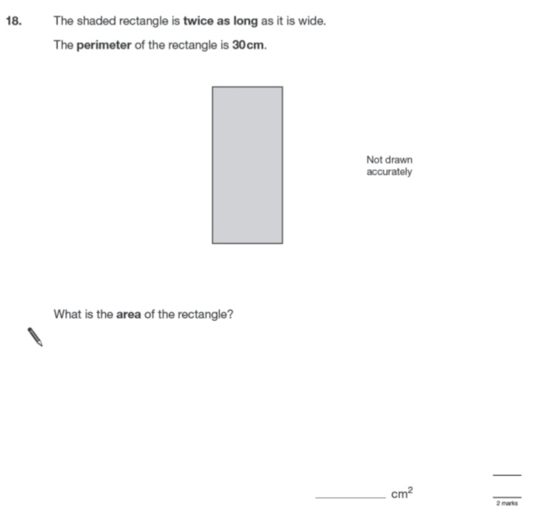
32.
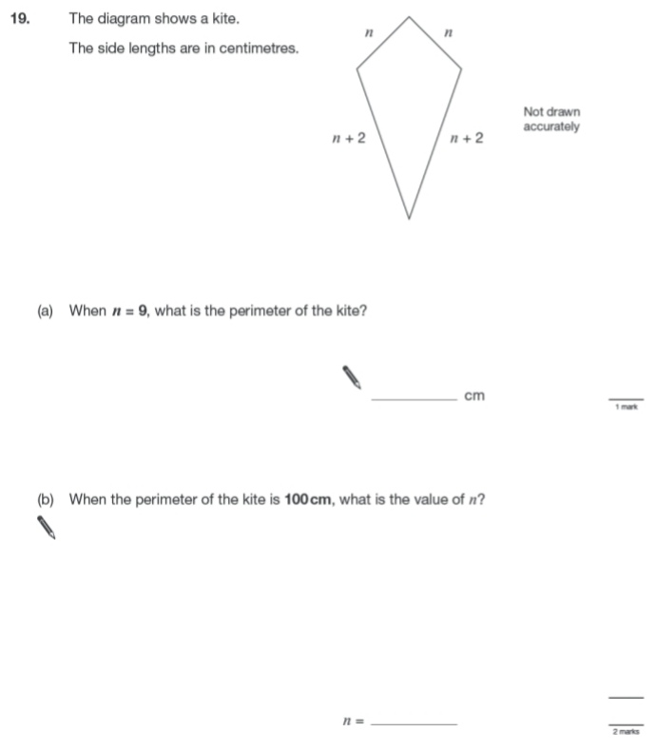
Key Stage 3: 2011 Paper 2 Level 4-6
33.
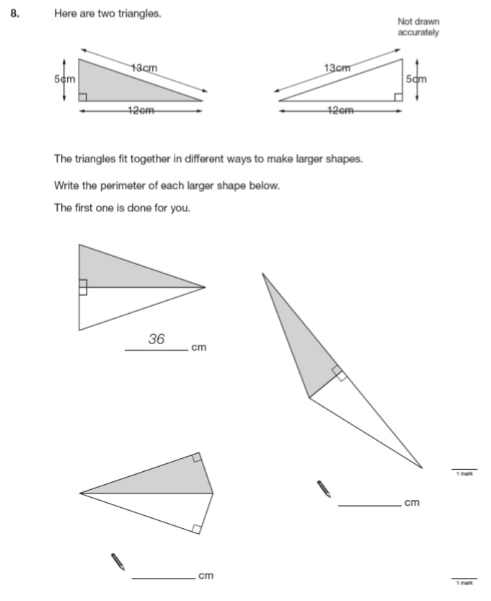
34.
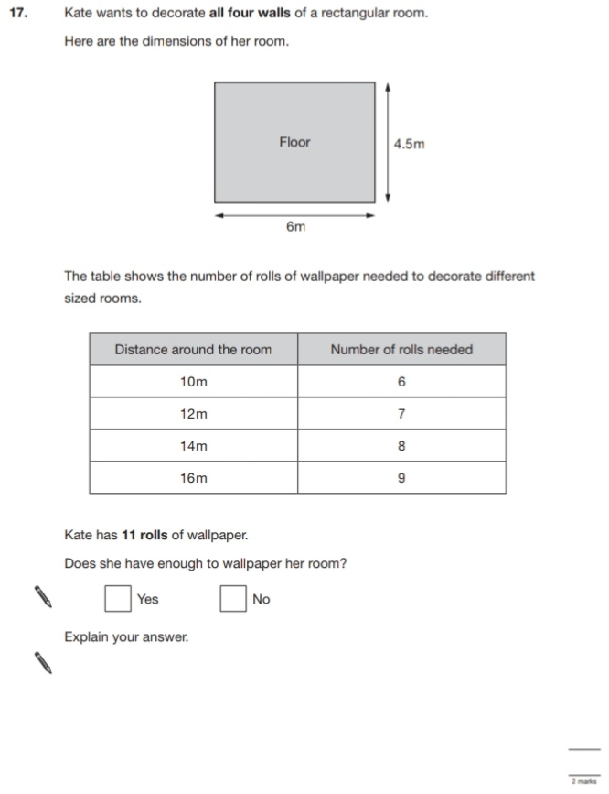
35.
36.
